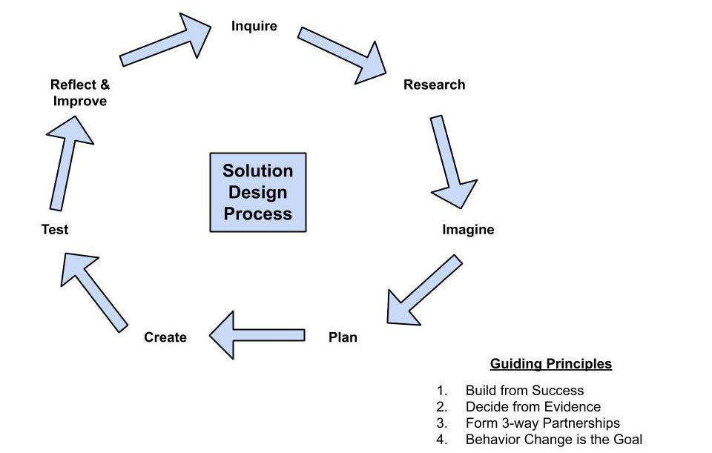
Inquire
What is the question you are trying to answer? What problem are you trying to solve?

Research
Has anyone else done something similar to what you are trying to do? Are their any past successes you can base your design off of? What did you learn from your research?

Imagine
What vision do you have for your project? What do you want to accomplish?

Plan
What steps do you need to take to bring your action project to life? Who do you need to work with? What materials do you need?

Create
Make a model of your plan either with a drawing or a written narrative of what you want to do, you can even build a small model and add a picture here.

Test
How will you determine if your action project is successful or not? What can you measure to prove if your project worked? Is there a way you can test your model?

Reflect and Improve
After you have tested your project or model how did it go? What went well? What didn’t go well? How can you improve your design to make it go even better next time?

